INTRODUCTION
The human body is a complex and highly organized system composed of multiple organ systems, each playing a vital role in maintaining life. These organ systems, including the circulatory, respiratory, digestive, nervous, musculoskeletal, and endocrine systems, work together to ensure the proper functioning of the body. Each organ within these systems performs specific tasks that contribute to overall health, homeostasis, and survival.
In recent years, the field of bio-designs has emerged as a groundbreaking discipline that combines biology, engineering, and medical sciences to develop innovative solutions for healthcare challenges. Advances in bioprinting, artificial organs, tissue engineering, and organ-on-a-chip technology have transformed the way we understand and treat organ-related diseases. These innovations offer promising solutions for organ failure, transplantation shortages, and regenerative medicine.
This seminar aims to explore the fundamental structure and function of human organ systems while examining the latest advancements in bio-designs. Understanding how these systems function and how technological innovations can enhance or replicate them is essential for the future of medical science and healthcare. Through this discussion, we gain insight into how bio-designs can revolutionize treatments, improve patient outcomes, and extend human longevity.

THE HUMAN ORGAN SYSTEM
- THE BRAIN
The human brain is the most complex organ in the body, responsible for controlling thoughts, emotions, memory, movement, and bodily functions. It is part of the central nervous system (CNS) and works alongside the spinal cord to process and relay information explained in the seminar in the fig.1.
Structure of the Human Brain
The brain is divided into three major parts:
- Cerebrum – The largest part of the brain, responsible for intelligence, reasoning, sensory perception, voluntary movement, and language. It is divided into two hemispheres (left and right) and further into lobes:
  - Frontal Lobe (decision-making, problem-solving, emotions)
  - Parietal Lobe (sensory processing, spatial awareness)
  - Temporal Lobe (hearing, memory, speech)
  - Occipital Lobe (vision processing)
- Cerebellum – Located at the back of the brain, it coordinates movement, balance, and posture.
- Brainstem – Connects the brain to the spinal cord and controls vital functions like breathing, heart rate, and digestion.
Functions of the Brain
- Cognitive Functions – Thinking, learning, and memory.
- Motor Control – Movement and coordination.
- Sensory Processing – Interprets signals from the senses (sight, sound, touch, taste, and smell).
- Autonomic Functions – Regulates involuntary actions like heartbeat, breathing, and digestion.
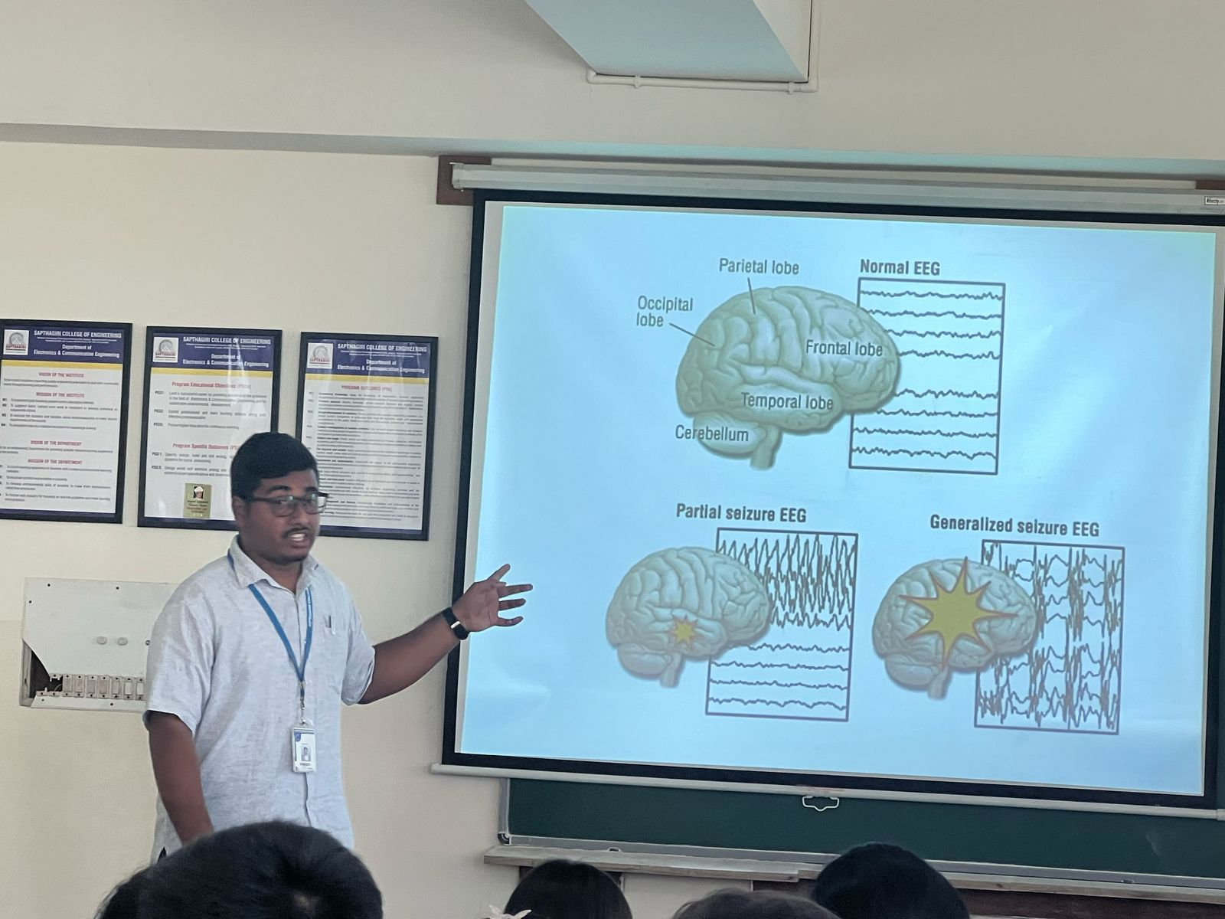

Fig.1 Seminar on Brain
Advancements in Brain Research & Bio-Designs
Modern science has made significant progress in understanding and enhancing brain functions through:
- Neuroprosthetics (Brain-Computer Interfaces for paralyzed individuals)
- Artificial Intelligence in Neurology (AI-driven diagnosis and treatment)
- Brain-Organ-on-a-Chip technology for drug testing
- Regenerative medicine (stem cell therapy for neurodegenerative diseases like Alzheimer's and Parkinson's)
The human brain remains one of the most intriguing and studied organs, with ongoing research in neuroscience and bio-designs paving the way for revolutionary medical advancements.

- THE EYES
The human eye is a highly specialized sensory organ that allows us to perceive light, color, and depth, enabling vision. It works like a biological camera, capturing light and converting it into electrical signals that the brain interprets as images.
Structure of the Eye
The eye consists of several key parts, each with a specific function explained in seminar fig.2.
- Cornea – The transparent, dome-shaped outer layer that helps focus light entering the eye.
- Iris – The colored part of the eye that controls the size of the pupil, regulating the amount of light entering.
- Pupil – The black circular opening in the center of the iris that expands or contracts based on light intensity.
- Lens – A transparent, flexible structure that changes shape to focus light onto the retina.
- Retina – A layer of light-sensitive cells (rods and cones) at the back of the eye that converts light into electrical signals.
- Optic Nerve – Transmits visual information from the retina to the brain for interpretation.
- Vitreous Humor – A gel-like substance that fills the space between the lens and retina, helping the eye maintain its shape.
How the Eye Works
- Light enters through the cornea and pupil.
- The lens bends and focuses the light onto the retina.
- The retina’s photoreceptor cells (rods for dim light, cones for color) convert light into electrical impulses.
- The optic nerve carries these impulses to the brain, which processes them into images.
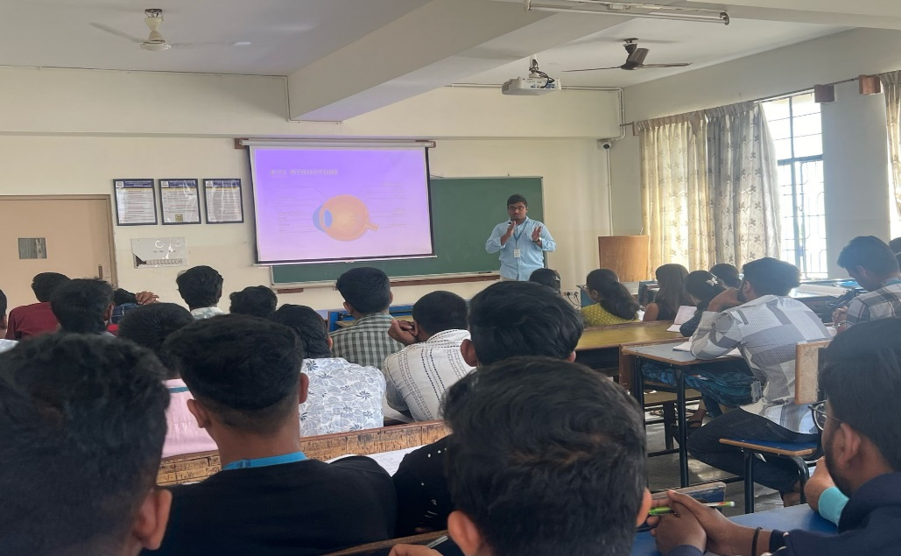

Fig.2. Seminar on Eye
Common Eye Disorders
- Myopia (Nearsightedness) – Difficulty seeing distant objects.
- Hyperopia (Farsightedness) – Difficulty seeing nearby objects.
- Cataracts – Clouding of the lens, leading to blurred vision.
- Glaucoma – Increased pressure in the eye, potentially causing blindness.
- Color Blindness – Difficulty distinguishing certain colors due to defective cone cells.
Bio-Designs & Advancements in Eye Research
- Bionic Eyes – Artificial implants to restore vision in blind individuals.
- Smart Contact Lenses – Lenses that monitor glucose levels for diabetics.
- Gene Therapy for Retinal Diseases – Experimental treatments to restore sight.
- 3D Bioprinting of Corneas – Creating artificial corneas for transplants.
The human eye is an incredible organ, and advancements in bio-designs continue to improve treatments for vision-related disorders, offering hope for millions worldwide.

- THE HEART
The human heart is a vital organ responsible for pumping blood throughout the body, supplying oxygen and nutrients while removing waste products. It is a muscular organ about the size of a fist, located slightly left of the center in the chest. The heart plays a crucial role in the circulatory system, working continuously to keep the body alive.
Structure of the Heart
The heart is divided into four chambers:
- Right Atrium – Receives oxygen-poor blood from the body via the superior and inferior vena cava.
- Right Ventricle – Pumps oxygen-poor blood to the lungs through the pulmonary artery for oxygenation.
- Left Atrium – Receives oxygen-rich blood from the lungs via the pulmonary veins.
- Left Ventricle – Pumps oxygen-rich blood to the rest of the body through the aorta.
The heart has four valves that ensure the one-way flow of blood:
- Tricuspid Valve (between the right atrium and right ventricle)
- Pulmonary Valve (between the right ventricle and pulmonary artery)
- Mitral Valve (between the left atrium and left ventricle)
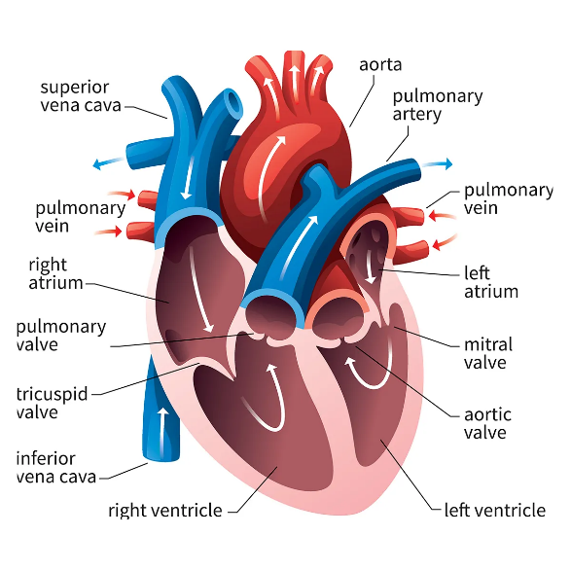
- Aortic Valve (between the left ventricle and aorta)

Fig.3.The Human Heart
How the Heart Works
- Deoxygenated blood from the body enters the right atrium and moves to the right ventricle.
- The right ventricle pumps blood to the lungs, where it gets oxygenated.
- The oxygen-rich blood returns to the left atrium and then flows into the left ventricle.
- The left ventricle pumps oxygenated blood to the entire body via the aorta.
- The cycle repeats continuously, ensuring constant circulation.
Common Heart Diseases & Disorders
- Hypertension (High Blood Pressure) – Increased force of blood against artery walls.
- Coronary Artery Disease (CAD) – Narrowing of heart arteries due to plaque buildup.
- Heart Attack (Myocardial Infarction) – Blockage of blood flow to the heart muscle.
- Arrhythmia – Irregular heartbeats that can be too fast, too slow, or erratic.
- Congenital Heart Defects – Heart abnormalities present from birth.
Bio-Designs & Advancements in Heart Research
- Artificial Hearts & Heart Pumps – Devices like the Total Artificial Heart (TAH) help patients with heart failure.
- Heart Stents & Bypass Surgery – Used to treat blocked arteries and improve blood flow.
- Gene Therapy & Stem Cells – Potential treatments for repairing damaged heart tissues.
The human heart is an extraordinary organ, working tirelessly to sustain life. Advances in bio-designs and medical technology continue to improve heart health and offer innovative treatments for cardiovascular diseases.

4.THE LUNGS
The human lungs are a pair of spongy, air-filled organs responsible for respiration. They allow the body to take in oxygen and expel carbon dioxide, playing a vital role in the respiratory system. Located in the chest cavity, the lungs work in coordination with the heart to oxygenate blood and remove waste gases.
Structure of the Lungs
The lungs are divided into two parts:
- Right Lung – Has three lobes (upper, middle, and lower).
- Left Lung – Has two lobes (upper and lower) and is slightly smaller to make space for the heart.
Key components of the lungs included in fig.4.
- Trachea (Windpipe) – The main airway that directs air into the lungs.
- Bronchi – Two large tubes that branch from the trachea into each lung.
- Bronchioles – Smaller tubes branching from the bronchi, leading to the alveoli.
- Alveoli – Tiny air sacs where oxygen and carbon dioxide exchange occurs.
- Diaphragm – A dome-shaped muscle beneath the lungs that helps with breathing.
How the Lungs Work
- Inhalation (Breathing In) – The diaphragm contracts, pulling air into the lungs.
- Air travels through the trachea → bronchi → bronchioles → alveoli.
- Oxygen from the air passes into the blood in the alveoli, while carbon dioxide moves from the blood into the alveoli.
- Exhalation (Breathing Out) – The diaphragm relaxes, pushing carbon dioxide out through the airways.
This process, known as gas exchange, is essential for supplying oxygen to body cells and removing waste gases.

Common Lung Diseases & Disorders
- Asthma – Inflammation and narrowing of the airways, causing breathing difficulties.
- Chronic Obstructive Pulmonary Disease (COPD) – A progressive disease that restricts airflow.
- Pneumonia – Infection that inflames the alveoli, leading to fluid buildup.
- Lung Cancer – Uncontrolled cell growth in lung tissues, often linked to smoking.
- Tuberculosis (TB) – A bacterial infection that affects the lungs.
Bio-Designs & Advancements in Lung Research
- Artificial Lungs & Lung Transplants – Scientists are developing bioengineered lungs for transplantation.
- Lung Assist Devices – Technologies like extracorporeal membrane oxygenation (ECMO) help support lung function in critically ill patients.
- Gene Therapy for Lung Diseases – Potential treatments for genetic conditions like cystic fibrosis.
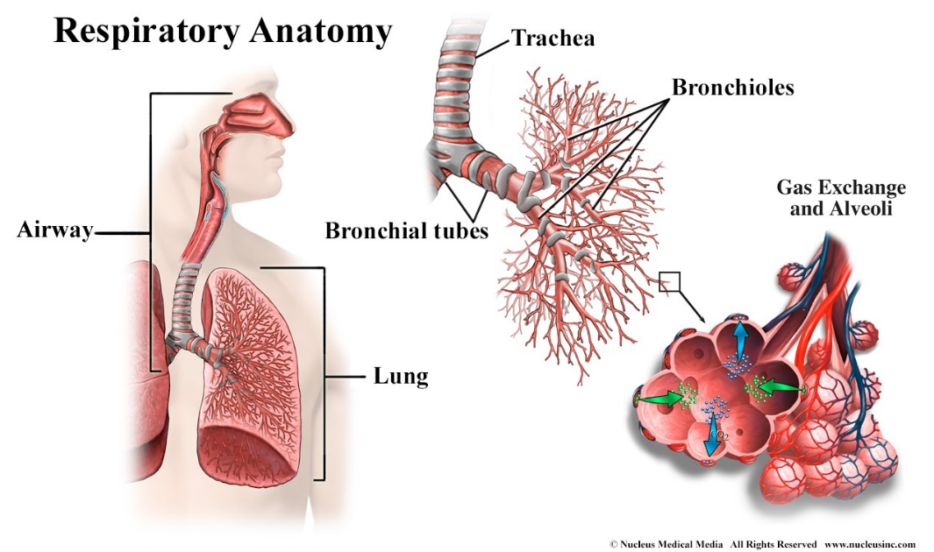
The human lungs are essential for life, and advancements in bio-designs and respiratory medicine continue to improve treatments for lung-related diseases, offering new hope for patients.

Fig.4.Human Lungs and Parts
- THE KIDNEY
The human kidneys are two bean-shaped organs located on either side of the spine, just below the rib cage. They play a crucial role in the excretory system, filtering waste, excess fluids, and toxins from the blood while maintaining electrolyte balance and regulating blood pressure.
Structure of the Kidney
Each kidney is about 10–12 cm long and consists of the following main parts:
- Renal Cortex – The outer layer where filtration begins.
- Renal Medulla – The inner part containing nephrons and structures called pyramids.
- Nephrons – The functional units of the kidney that filter blood and produce urine in fig.5.
- Renal Pelvis – A funnel-like structure that collects urine before passing it to the ureter.
- Ureter – A tube that carries urine from the kidney to the bladder.
Functions of the Kidneys
- Filtration of Blood – Removes waste, excess water, and toxins.
- Regulation of Electrolytes – Balances sodium, potassium, and calcium levels.
- Blood Pressure Control – Produces hormones like renin that regulate blood pressure.
- Red Blood Cell Production – Releases erythropoietin, which stimulates red blood cell formation.
- Acid-Base Balance – Maintains pH levels in the body.
Common Kidney Diseases & Disorders
- Chronic Kidney Disease (CKD) – Gradual loss of kidney function over time.
- Kidney Stones – Hard mineral deposits that cause pain and blockage.
- Urinary Tract Infections (UTIs) – Bacterial infections affecting the kidneys.
- Polycystic Kidney Disease (PKD) – A genetic disorder causing fluid-filled cysts in the kidneys.
- Acute Kidney Injury (AKI) – Sudden loss of kidney function due to injury or infection.
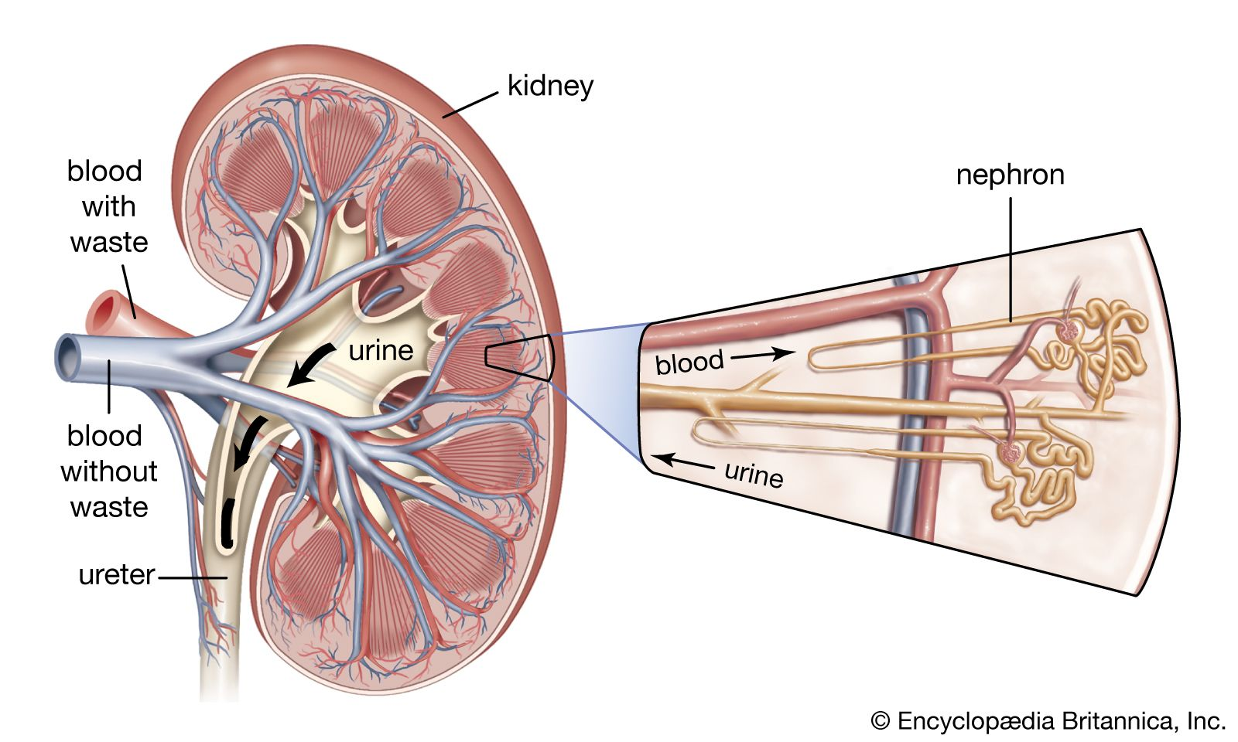
Fig.5.Human Kidney and Nephron
Bio-Designs & Advancements in Kidney Research
- Artificial Kidneys – Development of wearable or implantable kidney devices to replace
- Dialysis Innovations – Advanced hemodialysis and peritoneal dialysis techniques for kidney failure patients.
- Gene Therapy for Kidney Diseases – Potential treatments for genetic kidney disorders.
The kidneys are essential for detoxification and overall health, and advancements in bio-designs and regenerative medicine are transforming the treatment of kidney diseases, offering hope for millions worldwide.

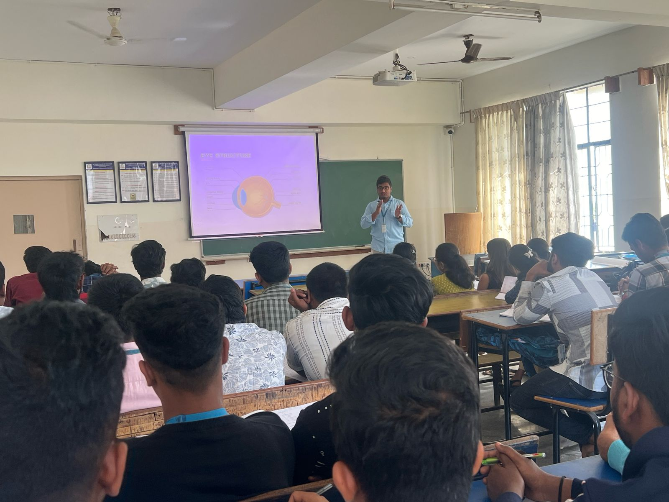
SEMINAR PHOTOGRAPHS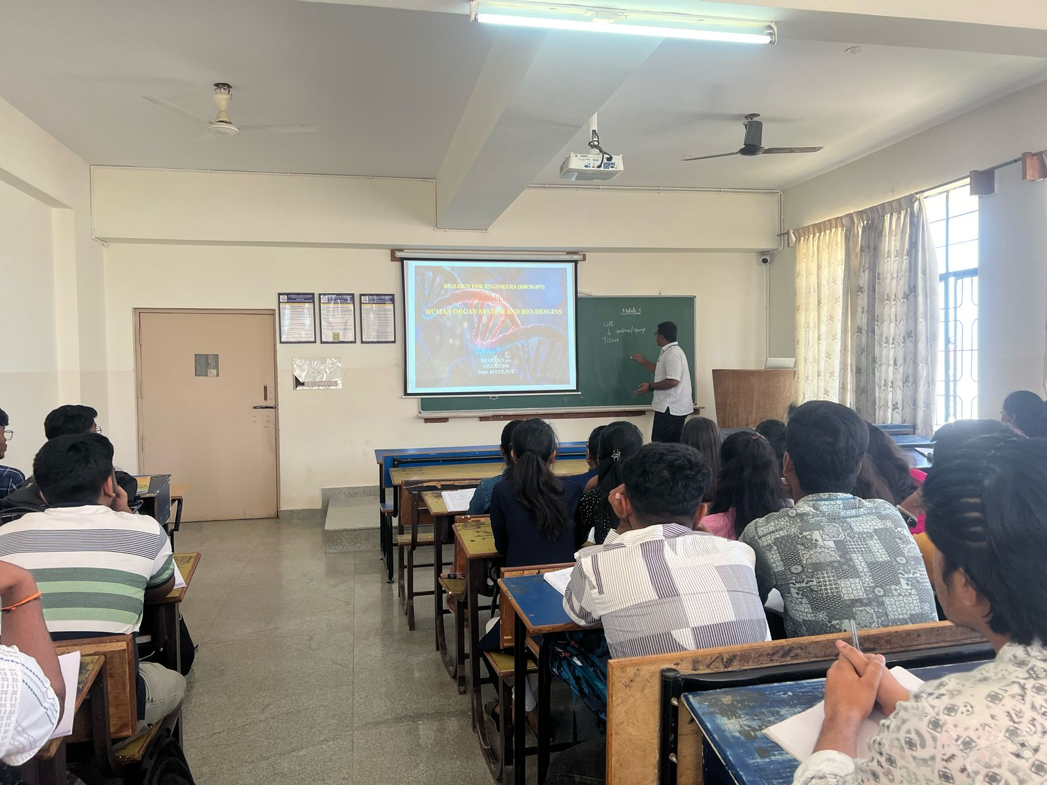

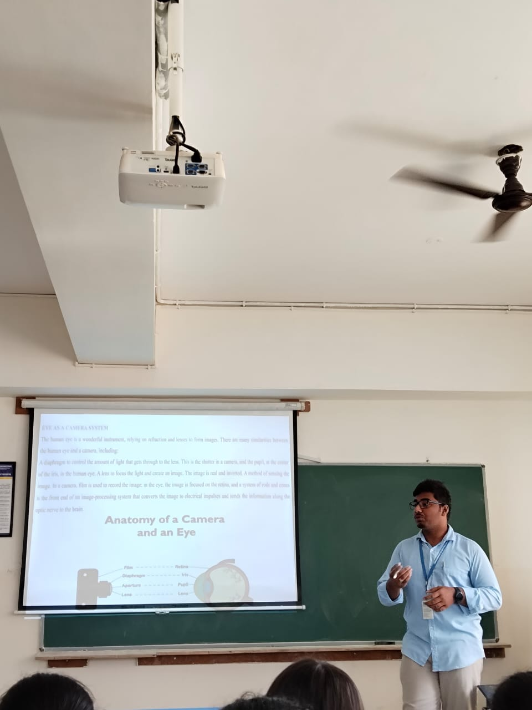

Fig.6.Seminar Conduction in Classroom

CONCLUSION
The human body is a remarkable and complex system composed of various organ systems that work together to maintain life. Each organ system has a unique function, contributing to processes such as circulation, respiration, digestion, excretion, and neural control. Understanding these systems is essential for advancing medical science and improving healthcare.
With the rapid progress of bio-designs, innovations like artificial organs, bioprinting, neuroprosthetics, and gene therapy are revolutionizing the treatment of organ-related diseases. These advancements not only enhance our ability to repair or replace damaged organs but also pave the way for more sustainable and accessible healthcare solutions.
As research continues, the integration of biology, engineering, and technology will lead to even more groundbreaking developments in regenerative medicine, personalized treatments, and improved organ transplantation techniques. The future of healthcare will rely on the synergy between human organ systems and bio-designs, ultimately improving the quality of life and extending human longevity.
By exploring the intricate design of human organs and the potential of bioengineering, we move closer to a future where medical challenges can be addressed with innovative, life-saving solutions.

REFERENCES
[1]. Biology for Engineers, Rajendra Singh C and Rathnakar Rao N, Rajendra Singh C and Rathnakar Rao N Publishing, Bengaluru, 2023.
[2]. Human Physiology, Stuart Fox, Krista Rompolski, McGraw-Hill eBook. 16th Edition, 2022 Biology for Engineers, Thyagarajan S., Selvamurugan N., Rajesh M.P., Nazeer R.A., Thilagaraj W., Barathi S., and Jaganthan M.K., Tata McGraw-Hill, New Delhi, 2012.
[3]. Biology for Engineers, Arthur T. Johnson, CRC Press, Taylor and Francis, 2011
[4]. Biomedical Instrumentation, Leslie Cromwell, Prentice Hall 2011.
[5]. Biology for Engineers, Sohini Singh and Tanu Allen, Vayu Education of India, New Delhi, 2014
[6]. https://www.nih.gov/
[7]. https://www.who.int/
[8]. https://pubmed.ncbi.nlm.nih.gov/

